**Jayshree**

Contact no: **+918296519967**

Email id : **jayshreejaya86@gmail.com**

# Career Objective:

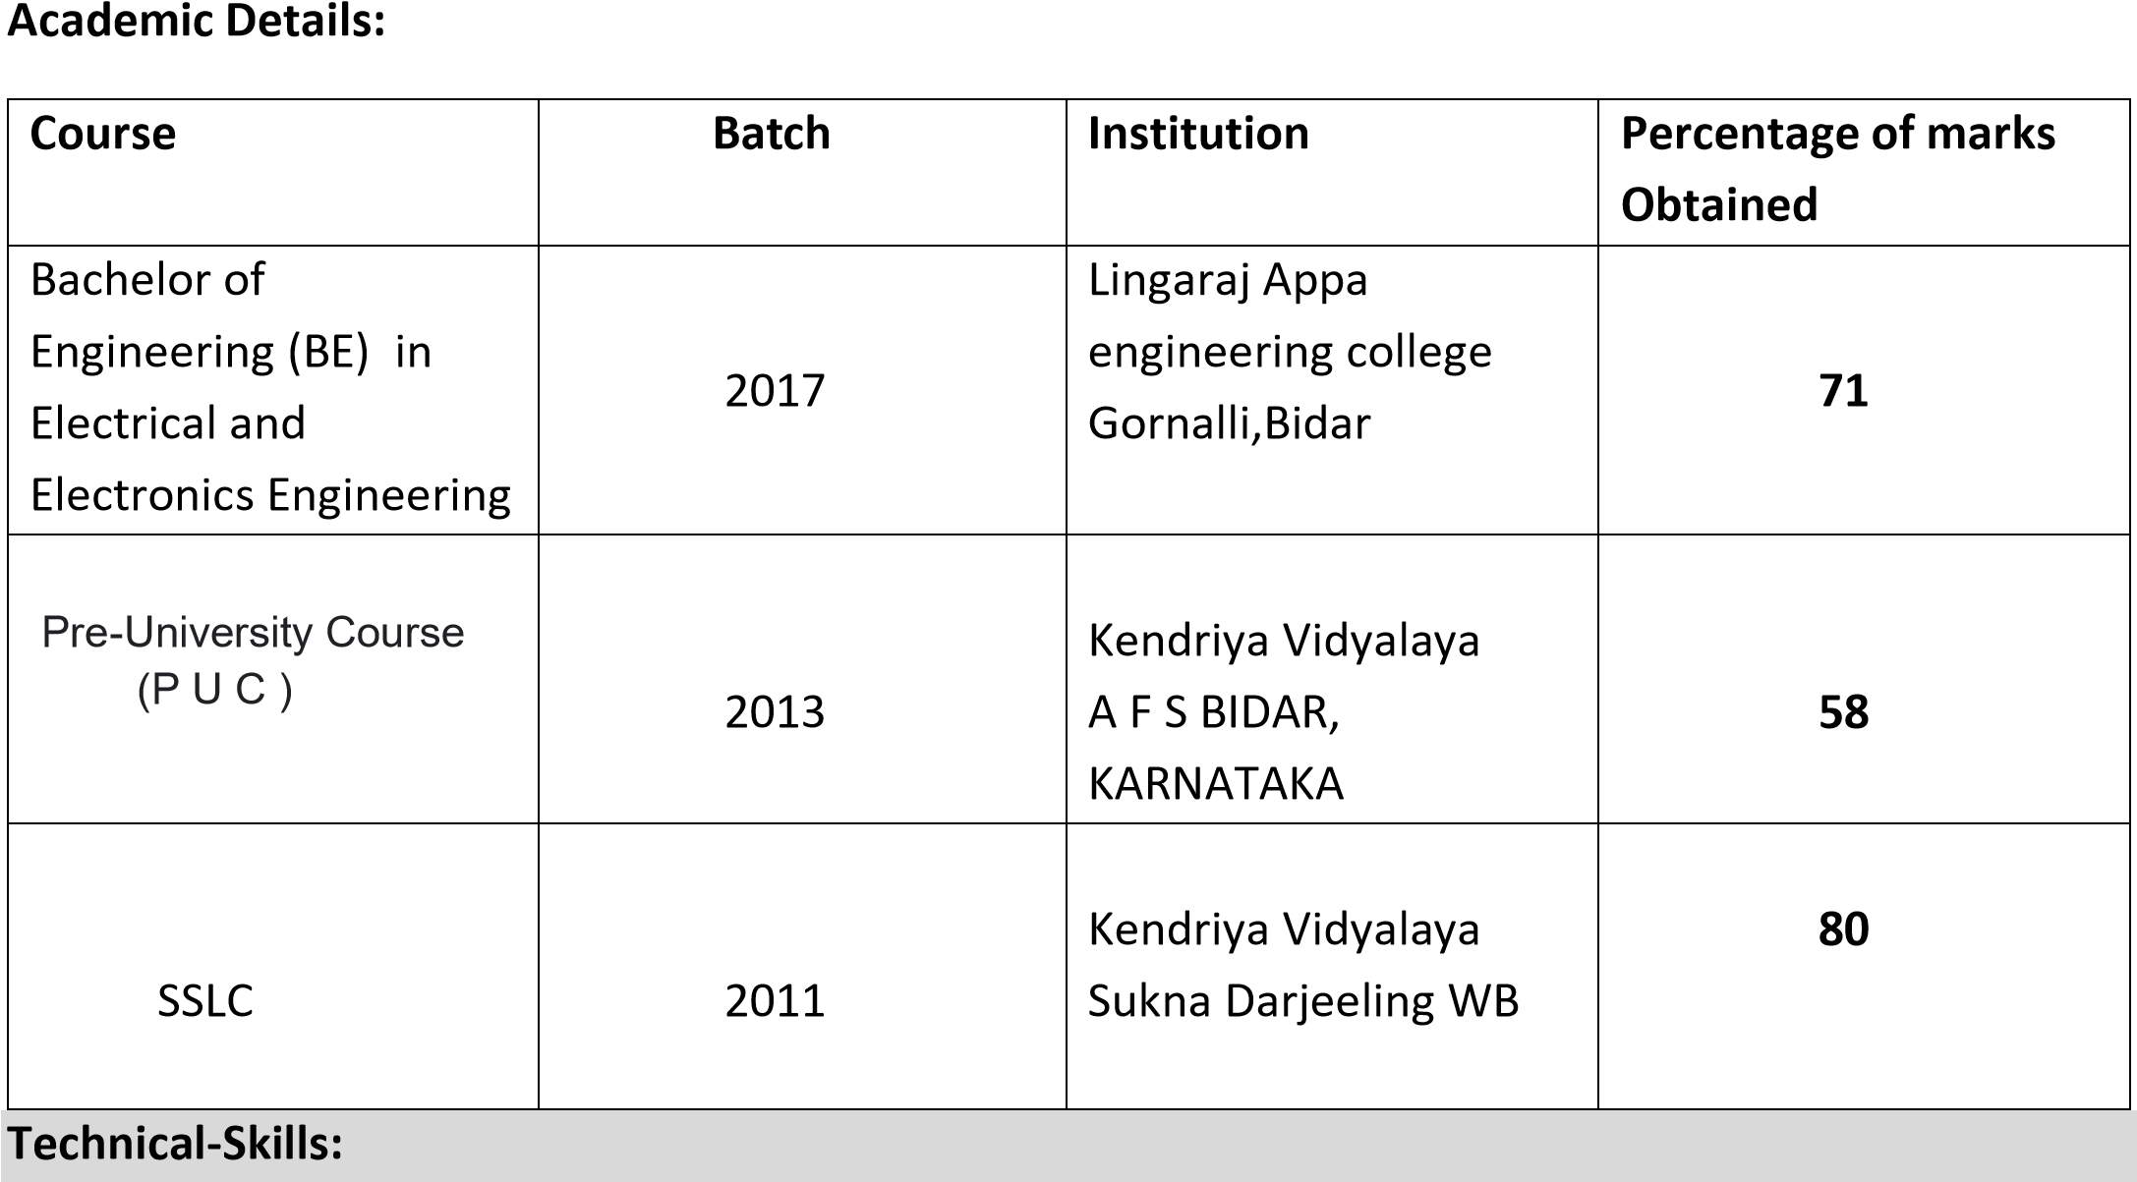To seek for a job in challenging and healthy environment that provides me satisfaction and self development by utilizing my skills and knowledge efficiently for organizational growth.

1.HTML

2.CSS

3.JQUERY

4.BOOTSTRAP

5.PHOTOSHOP

6.JAVASCRIPT

7.REACT

**Engineering project:** Foot step power generation system.

# Areas of Strengths:

* Quick learner.
* Good communication skill.
* Team player and hard working.

# Areas of interest:

**Sports** : Cricket, Chess.

**Hobbies** : sketching,Reading,Listening Music .

# Personal Details:

**Name** **:** Jayshree

|  |  |
| --- | --- |
| **DOB** | **:** 7-July-1995 |
| **Sex** | **:** female |
| **Father’s name** | **:**Bandappa CH |
| **Address** | **:** H.No 9-5-609/1 near new water tank Adarsh Colony Bidar, Karnataka 585401. |

**Contact number** **:** +91 8296519967

**Nationality** **:** Indian

**Languages known :** English, Hindi, Kannada.

# Work Experience:

Internship experience of one month in front end development..

# Declaration:

I am here by declaring that all the documents that’s mentioned above is true and correct to the best of my knowledge.

**Your’s regards**